

**Maroondah M.A.D.ness**

**Making a Difference**

**Newsletter Issue 2 December 2021**

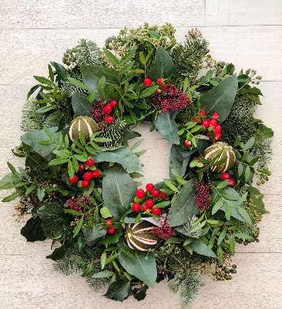**A Christmas Note from President Mark**

[This Photo](http://blog.shinekapoor.com/2014/04/thinking-cap-to-z-challenge-april-2014.html) by Unknown Author is licensed under [CC BY-SA](https://creativecommons.org/licenses/by-sa/3.0/)

As we approach the end of another challenging year, I would like to take this opportunity to thank all the members for your extraordinary support of our club during 2021. In particular, I would like to thank John Harding-Smith for his leadership during the first half of the year and then for taking on the responsibility for membership and marketing. A huge thank you also goes to the board members for their wonderful leadership of the club.

Our new members, Trish McGee and Darrin Scott have hit the ground running with their active involvement in committees. During 2022 I look forward to

enjoying the benefits of their experience and skills as club involvement develops

and strengthens.

During my presidential year I have been thrilled that the club has been able to run our main fundraisers. These events involve a huge amount of time and energy, organisation and leadership and I would like to acknowledge my gratitude to the committees: thank you to Wendy Scott for the Rice Meal, Roger Smith and the committee for the magnificent Golf Day, and to Andrew Brownlee and Donna Harding-Smith for the Trailer Raffle which is an enormous commitment.

I very much appreciate that members, both active and honorary, have been able to devote time to actively supporting these events, some members even taking holidays or leave in order to do so.

In closing, I would like to wish all members a safe and happy Christmas. I hope you are able to spend time with family and friends and enjoy the summer. I look forward to 2022 and what I hope will be an easier year for all.

**Another Successful Golf Day**

Despite a very windy day, our Charity Golf Day was once again a success with 100+ players.

The Golf Committee stoically planned the day through lockdowns and COVID restrictions and were elated that they were going to finally be able to go ahead with the day. Thanks to their hard work and that of club members and volunteers, the day ran smoothly with many players saying they can’t wait until next year’s event.

On talking to many of the players after the game they said they were there to have a fun day and support the causes we back. In fact, at the bar, we collected a number of donations. All in all, the day made a nice profit which we can use for various projects in the future or throughout the year.

**Christmas Breakup**

After a long year of lockdowns, modifying the way we do things to comply with Covid restrictions and Club members keeping in touch through Zoom meetings, we are excited to be able to proceed with a face to face Christmas celebration at Club Kilsyth on Wednesday, 8th December at 6.30 for 7pm. Phew!! We have finally made it!!!

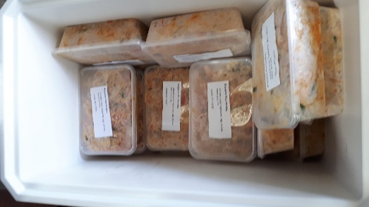**Helping Those Less Fortunate Than Ourselves**

After feeding our hungry golfers with Lillie’s noodles, there

were some cooked noodles left over at the end of the golf day.

Marilyn L took these home, put them into 25 smaller containers and froze them overnight. She has taken them to a Lilydale

food relief agency to be handed out this week. Two benefits

were achieved reducing waste and helping others in need.

**Some dates to remember**

Our club has made a commitment to help at this event

District has asked we make our members aware of these events in January and February**.**

***Birthdays for December Birthdays for January***

**Tim T 8th Darrin S 1st**

**Donna 18th  Roger D 5th**

**Phil N 30th John H-S 20th**

***Hope you all have a special day***

**First Rotary Get Together for 2022**

President Mark has booked Heathmont Bowls Club at 9 The Greenway, Heathmont for our first get together in the new year.

Last year it was a tip top night. We all took our own BBQ food and were able to purchase drinks from the bar at the bowling club. They were very reasonable from what I remember.

Some members then entertained the other members with their lawn bowling skills, or lack of skill. It was a nice relaxing night to allow us to slip back into the new year after busy Christmas

festivities and to exchange any news with each other.

**What’s on, at a glance:**

|  |  |  |
| --- | --- | --- |
| **Date** | **Event** | **Time** |
| Dec 1-21 | Rotary Trailer Raffle at Eastland |  |
| Dec 8 | Club Christmas Break Up in Canterbury Room, Club Kilsyth | 6.30pm |
| Jan 19 | First Rotary Meeting for the year at Heathmont Bowls | 6.30pm |
| Feb 27 | Rotary Storm Recovery Festival Monbulk Reserve, Monbulk | 10am |
| Mar 25 & 26 | District 9810 Conference |  |

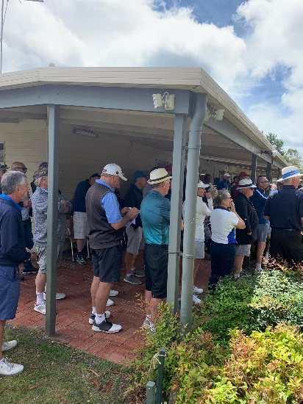

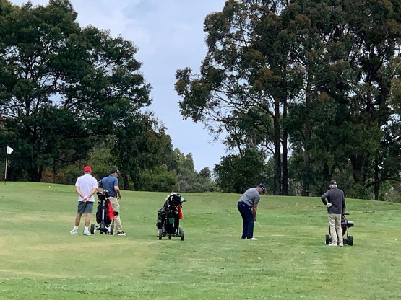

**Golf Day Photos**

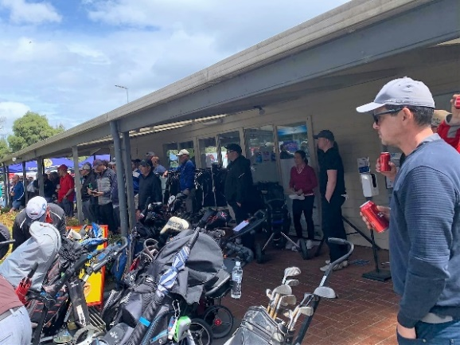

Wishing you all a very Merry Christmas and Happy New Year